**Coursework 2- Social Networking Website**

**Name: Dristi Bhugun**

**Student ID: M00846514**

**Module: CST 2120 Web Application**

**Date of submission: 12/04/24**

**Tutor: Mrinal Sharma**

**TABLE OF CONTENTS**

Introduction 4

How to use TrekTeller? 4

HTML and CSS Validation 5

Web Service 6

Security, Privacy Legal Issues 11

Advanced website functionality 11

Screenshots of website 13

Conclusion 17

**TABLE OF FIGURES**

**1** POST method to create a new post 7

2 Creation of post in MongoDb Atlas 7

3 PUT method to update user profile 8

4 Output of PUT method 8

5 Updated Profile in MongoDB 9

6 GET method to fetch all posts 9

7 GET method to display user data 10

8 Displaying user data in front end 10

9 Users Page with Message Option 11

10 ChatsPage 12

11 HomePage | TrekTeller 13

12 Signup Page | TrekTeller 14

13 Login Page | TrekTeller 14

14 Dashboard | TrekTeller 15

15 Post Description 15

16 Create a Post Form 16

17 Profile Page 16

# Introduction

Welcome to TrekTeller, a vibrant community where travel enthusiasts from around the world converge to share their adventures, tips, and wanderlust-driven tales. Whether you're a seasoned globetrotter or a budding explorer, our platform invites you to connect with like-minded individuals, offering a space to post your travel plans and captivating blogs. With an intuitive design and interactive features, TrekTeller, crafted using HTML, Tailwind CSS, JavaScript, AJAX, Node.js, and MongoDB, ensures a seamless and engaging user experience. Join us on this digital journey, where every click unveils a new destination and each post sparks inspiration for your next adventure.

As you navigate through TrekTeller, you'll discover a user-friendly interface that encourages interaction. Login and Sign-Up effortlessly using Node.js and MongoDB, and delve into a world of travel insights. Engage with fellow explorers through likes, comments, and shares, transforming your digital presence into a travel narrative that resonates with others. Our navigation bar simplifies your exploration, guiding you to pages such as 'About Us,' 'Login,' ‘Signup’ and the essential 'Home' button. With a commitment to fostering connections, recognizing achievements, and sparking wanderlust, TrekTeller is your go-to destination for all things travel. Unpack, share, and explore – Adventure Awaits!

# How to use TrekTeller?

**Signup for TrekTeller**

* Go to signup page
* Enter username and password to create an account
* Click on Signup button.
* Your account will be created

**Login**

* Go to login page
* Enter your username and password for login the website.
* Click on login button

**Posts**

* Users can view posts of any user and use filter according to continents
* Users can like and comment on any post.

**Post a story**

* Any registered user can post a story and it will be displayed to users.
* Users can upload images in posts to make it attractive.

**Chat**

* Users can message to each other in this website.

# HTML and CSS Validation

HTML validation for index.html file



CSS validation from jigsaw

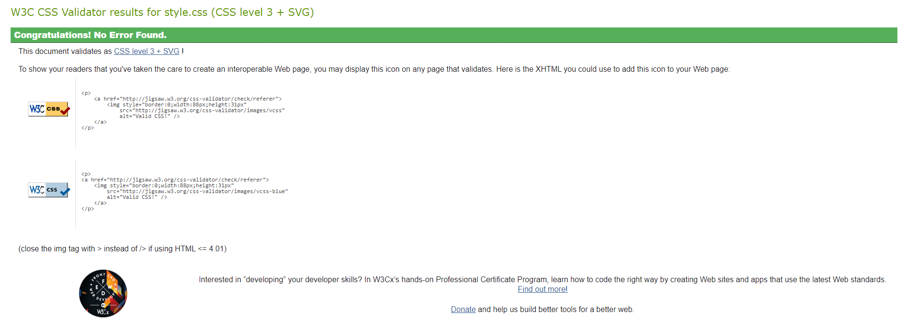

# Web Service

User can create new post by clicking on post a story it will fetch /M00846514/newpost with POST method.

**For example:**

Creating a new post by fetching <http://localhost:3000/M00846514/newpost> with method POST.

After entering required data for creating a post click on SEND button.

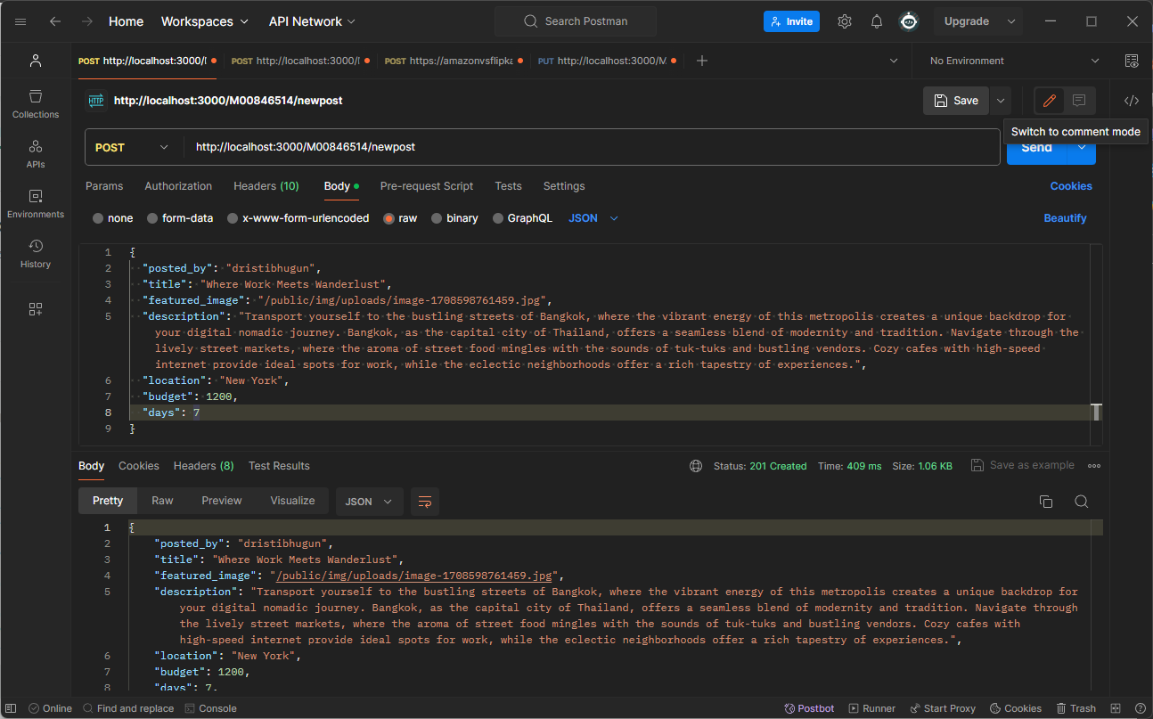

**1** POST method to create a new post

New post is saved in posts collection in MongoDB Atlas.

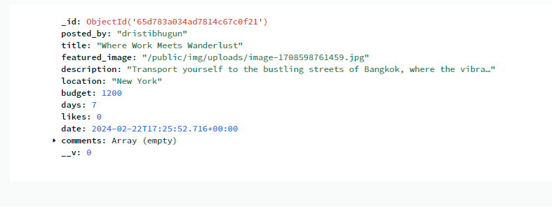

2 Creation of post in MongoDb Atlas

To update user profile, user can fetch <http://localhost:3000/M00846514/updateProfile> with PUT method

**For example:**

If we only want to update email of user “M00846514”, then we pass email as db1178@live.mdx.ac.uk

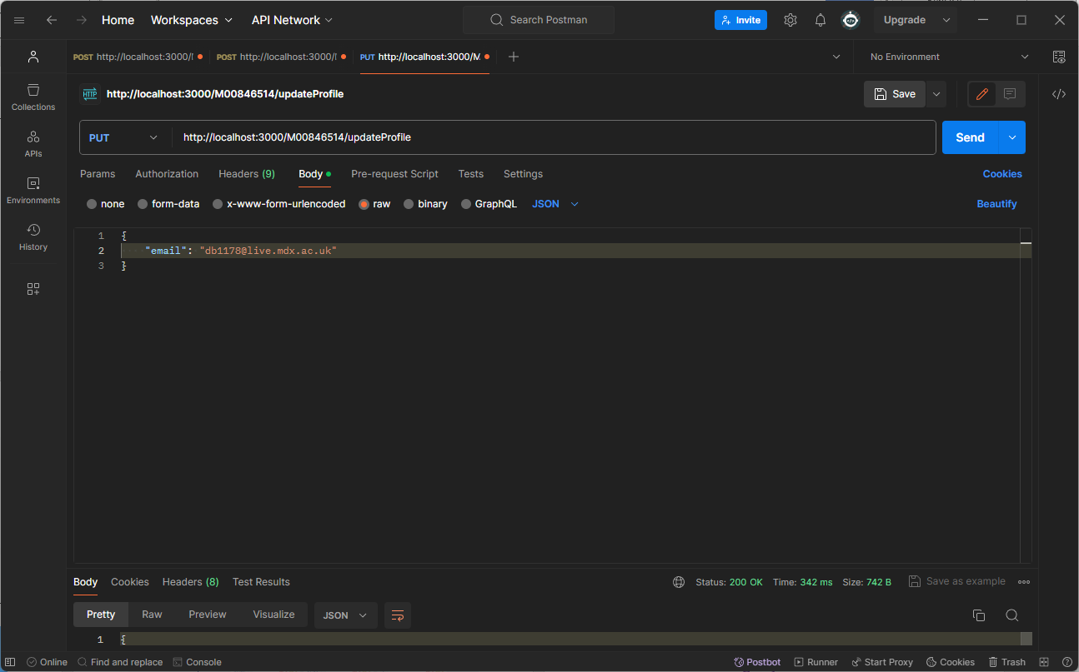

3 PUT method to update user profile

When we click on send, it will be updated and updated response will be displayed

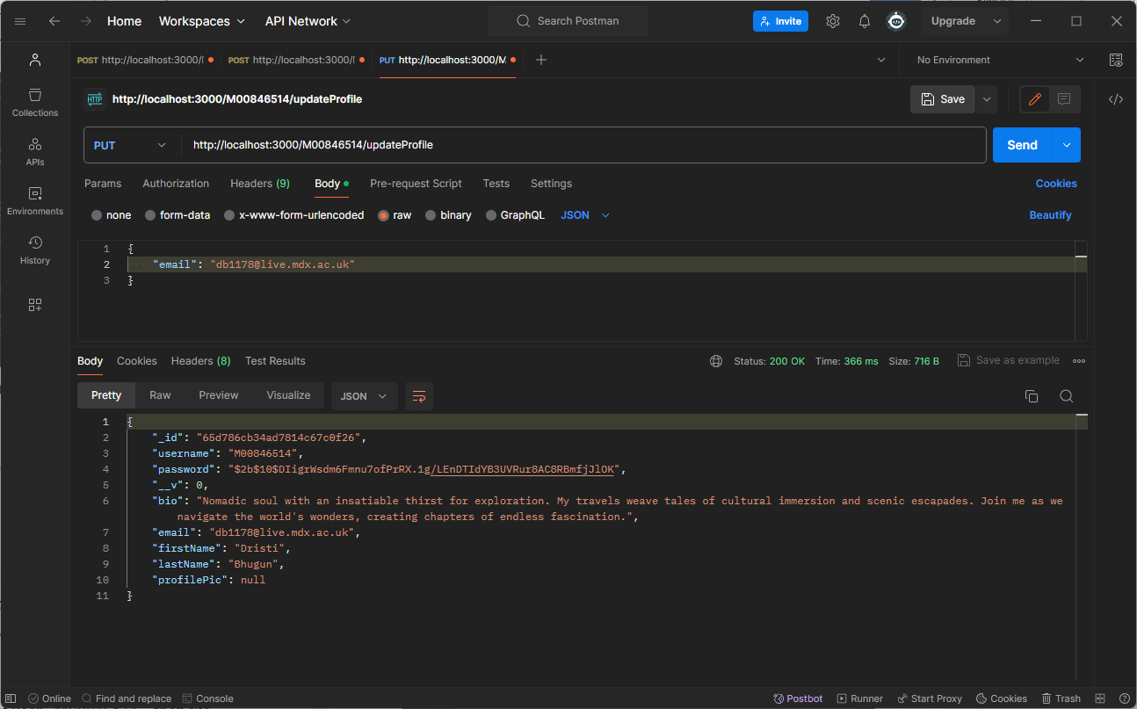

4 Output of PUT method

We can also see updated email in database

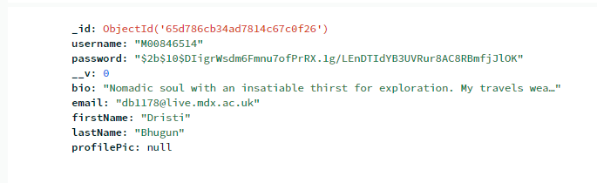

5 Updated Profile in MongoDB

Updated email is showing in MongoDB.

To view all posts from database, we fetch /M00846514/posts with GET method



6 GET method to fetch all posts

All posts from “posts” collection will be displayed.

When user opens profile data will be retrieved from MongoDB with GET method from / M00846514/profile

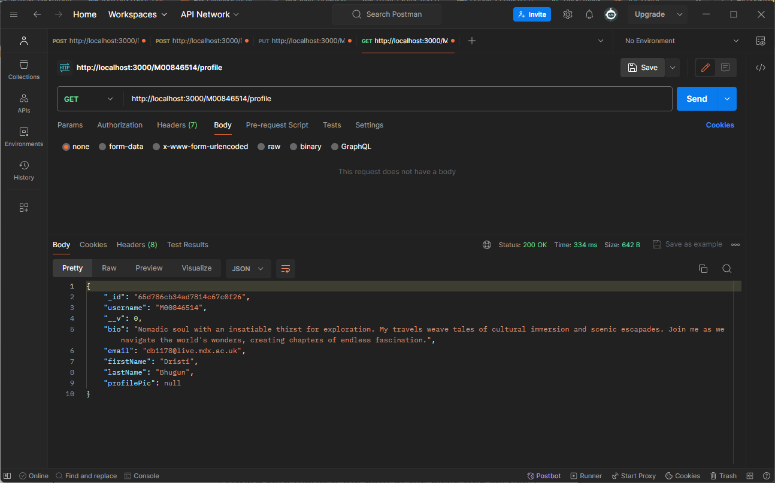

7 GET method to display user data

Profile data is used to display user profile in #/profile

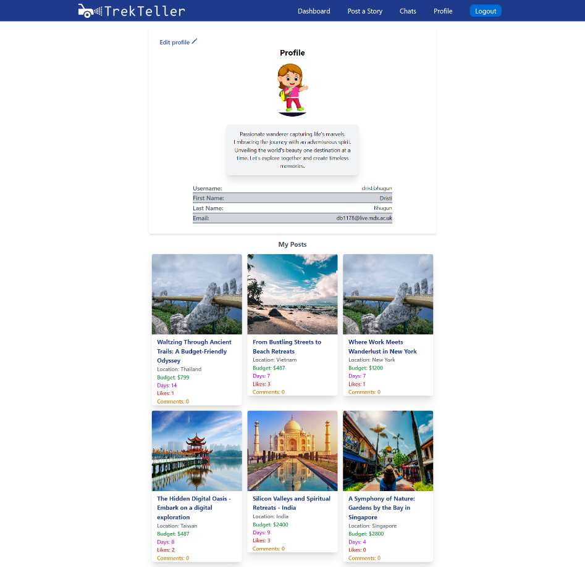

8 Displaying user data in front end

# Security, Privacy Legal Issues

* All sensitive data such as jwt_key, MongoDB cluster URL and Port are saved in .env file.
* These secrets will be used when we want to deploy it on production.
* We can store these as GitHub Repository Secrets.
* Images used for posts are royalty-free images.

# Advanced website functionality

For advanced web functionality, I’ve added chatting option in TrekTeller website. Users can text any user they want in it.

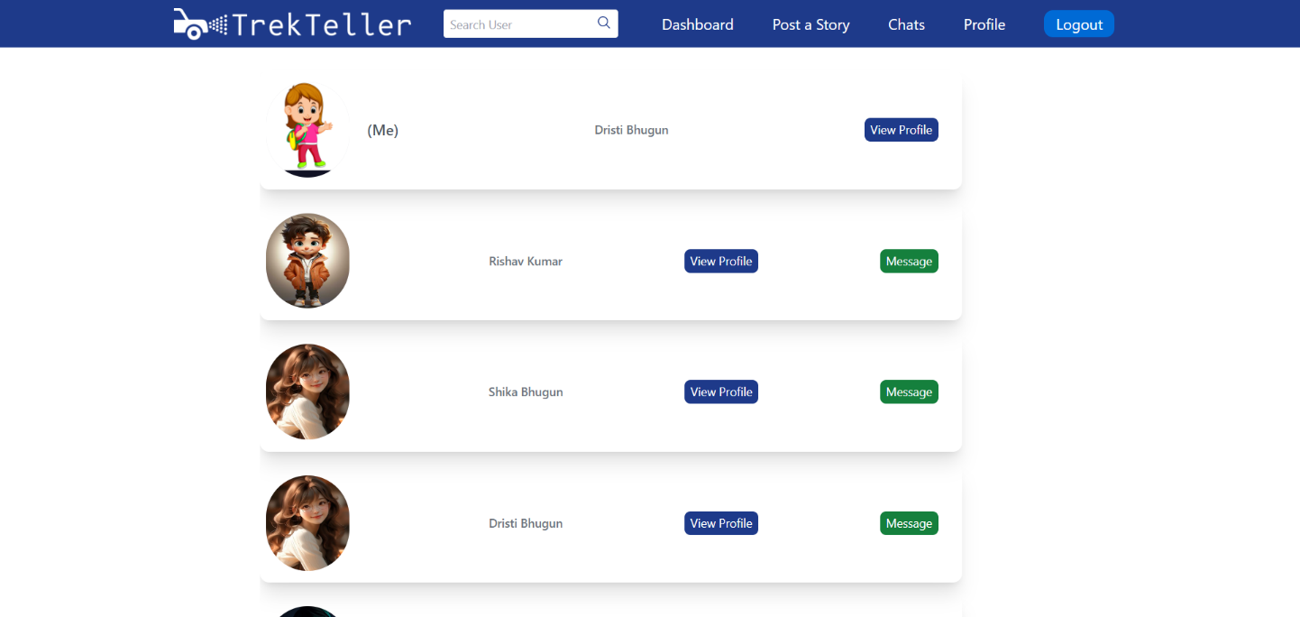

9 Users Page with Message Option

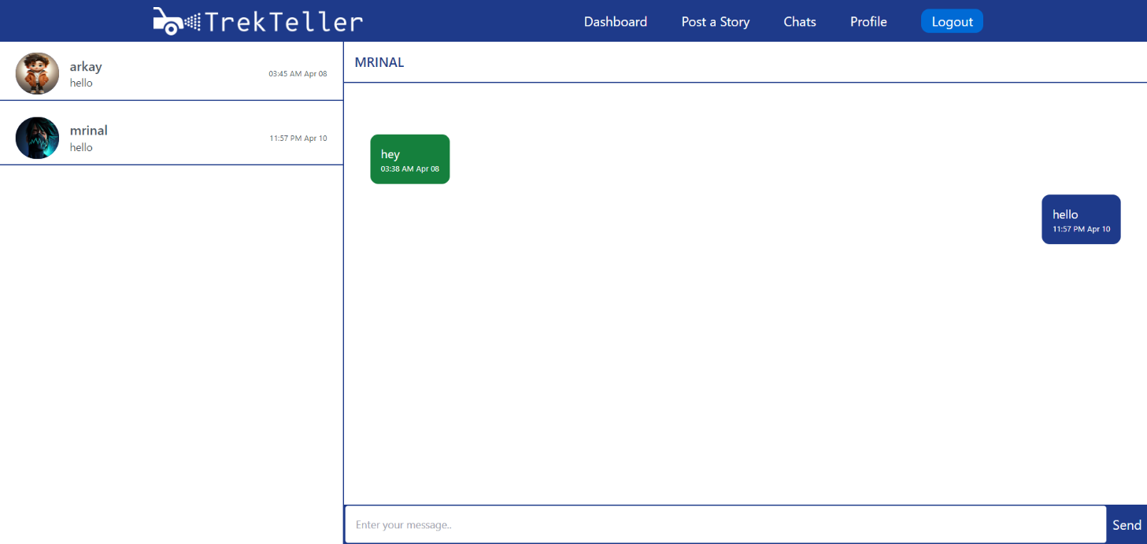

10 ChatsPage

# Screenshots of website

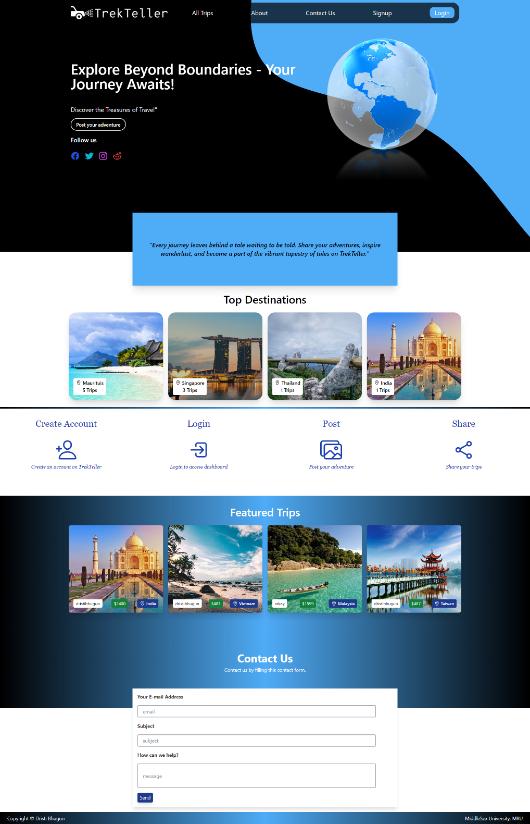

11 HomePage | TrekTeller

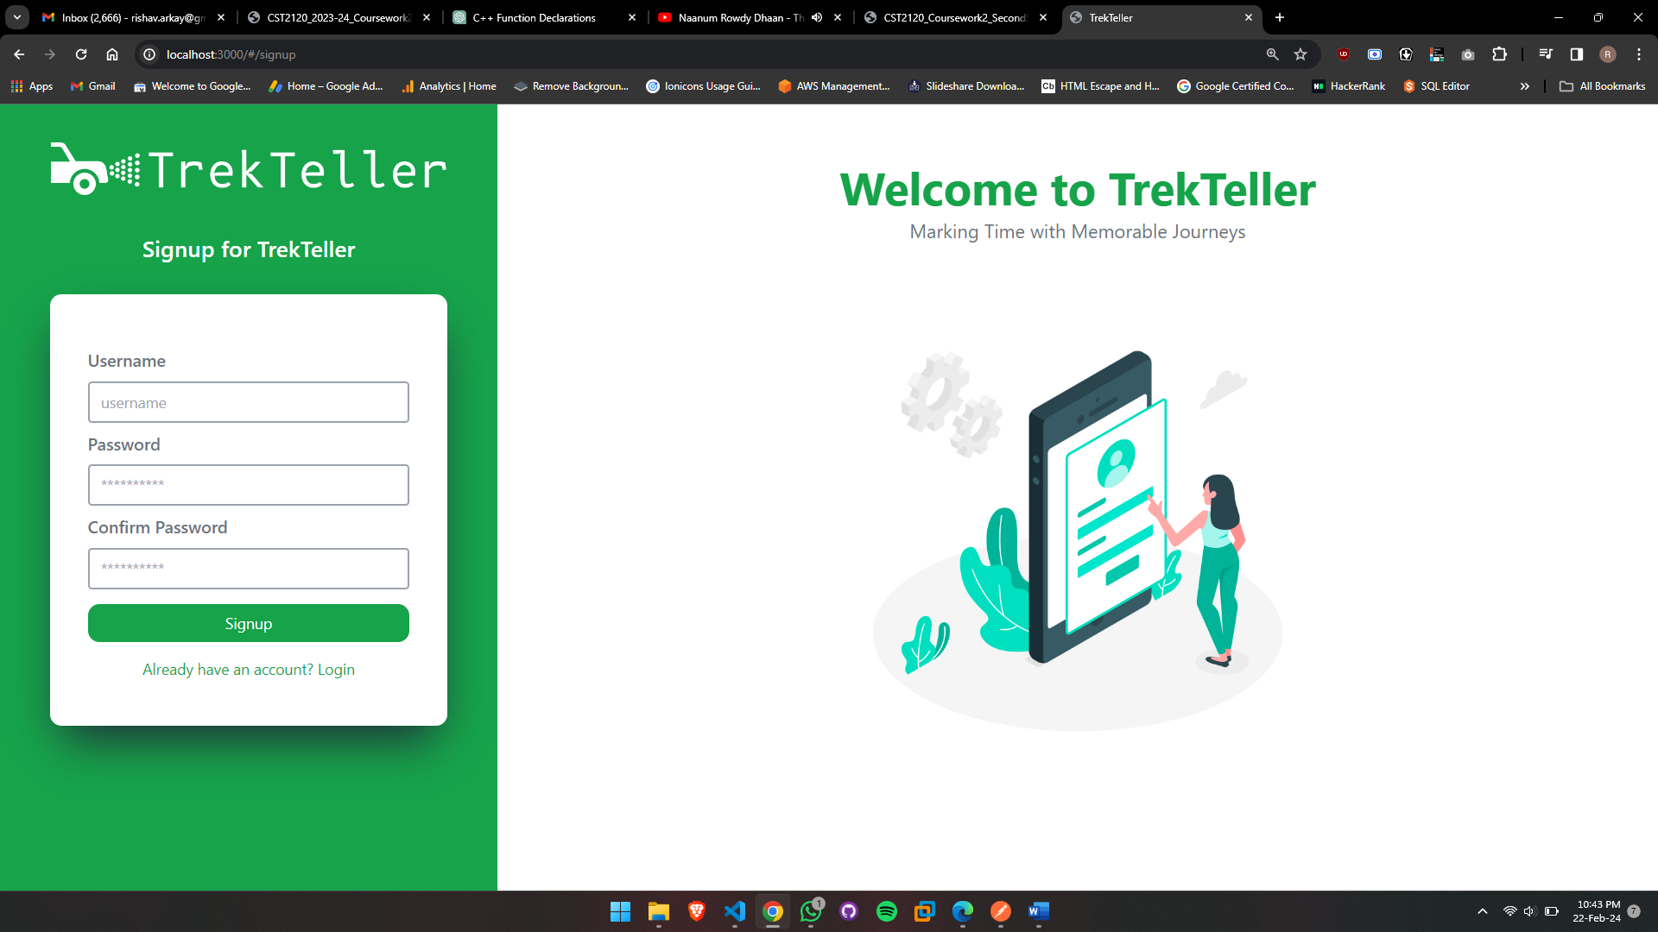

*12* Signup Page | TrekTeller

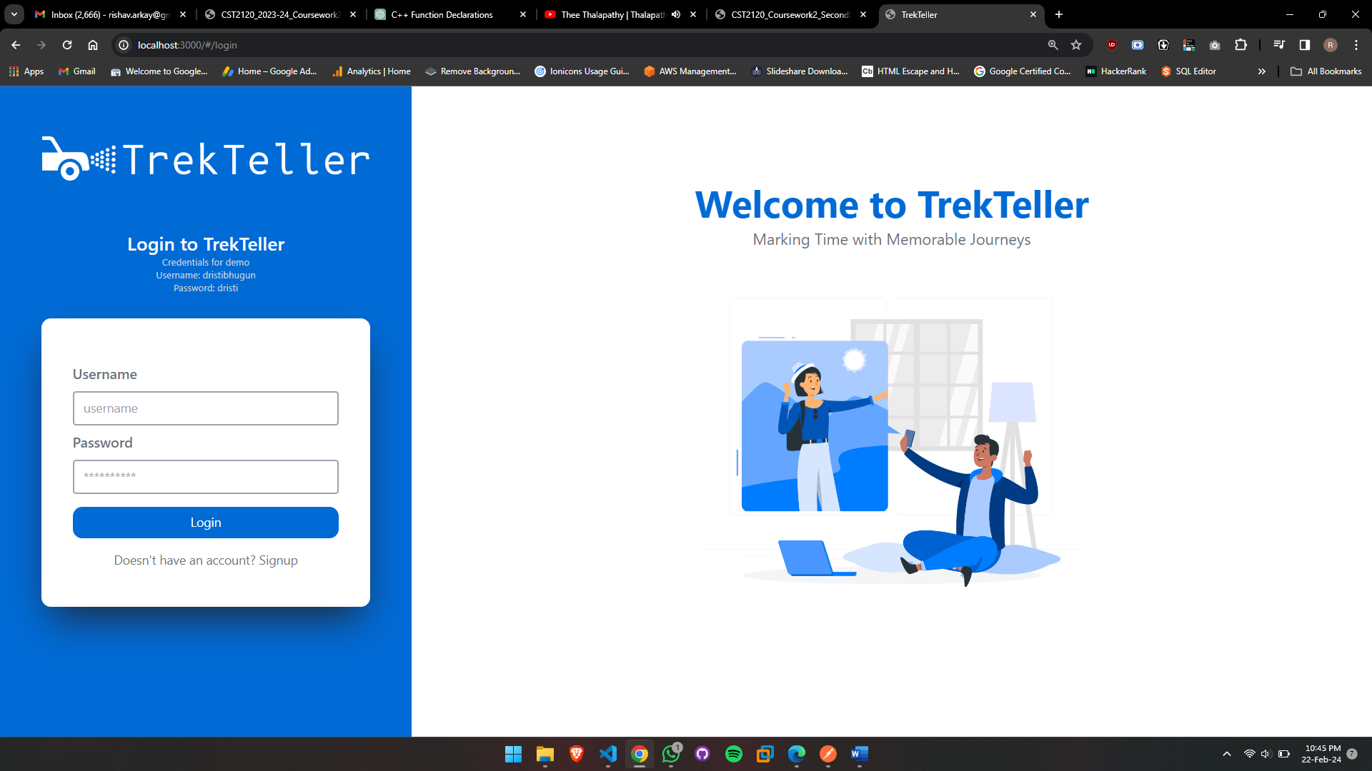

13 Login Page | TrekTeller

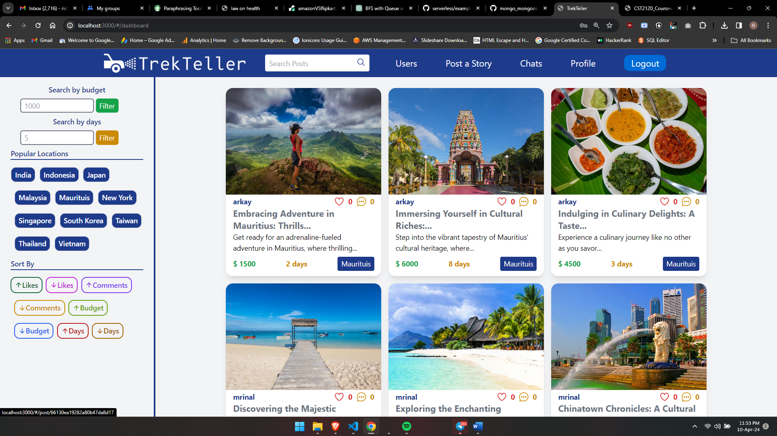

14 Dashboard | TrekTeller

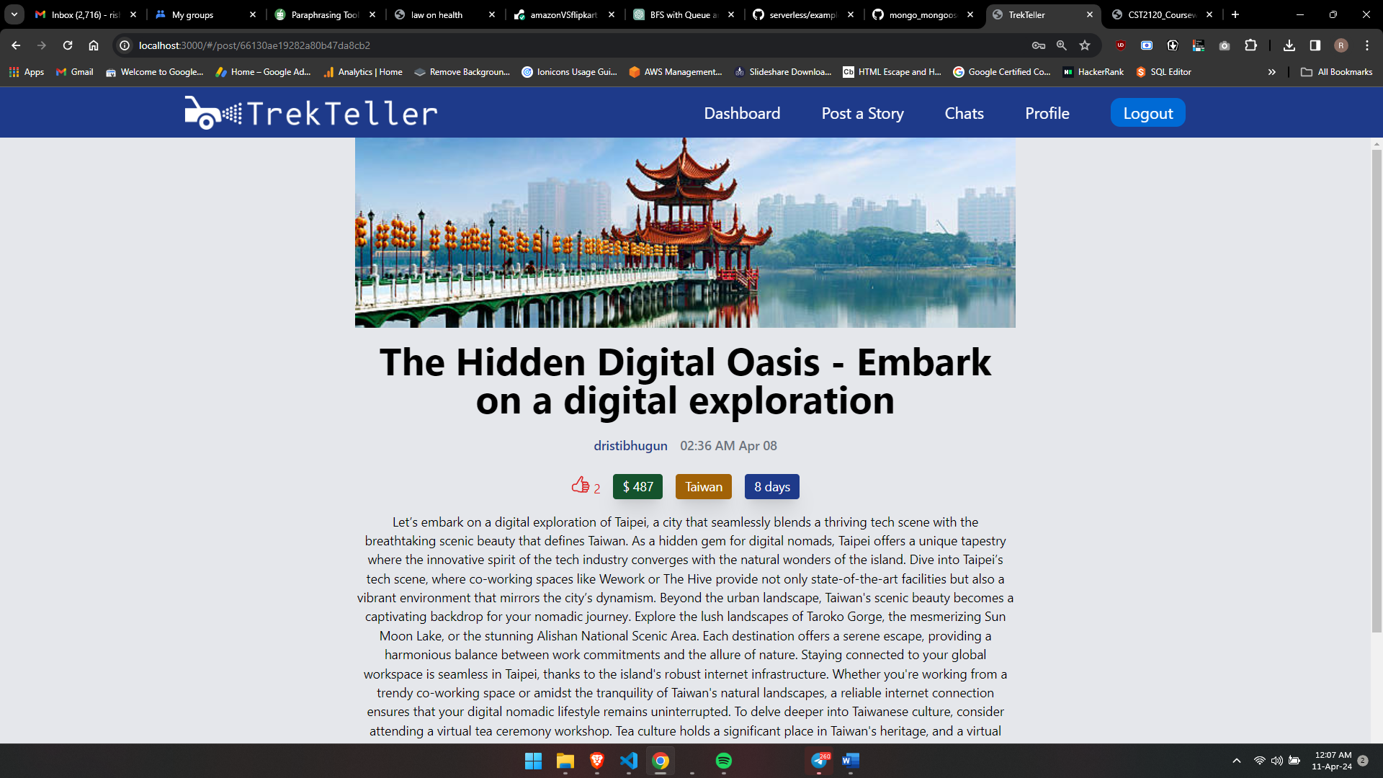

15 Post Description

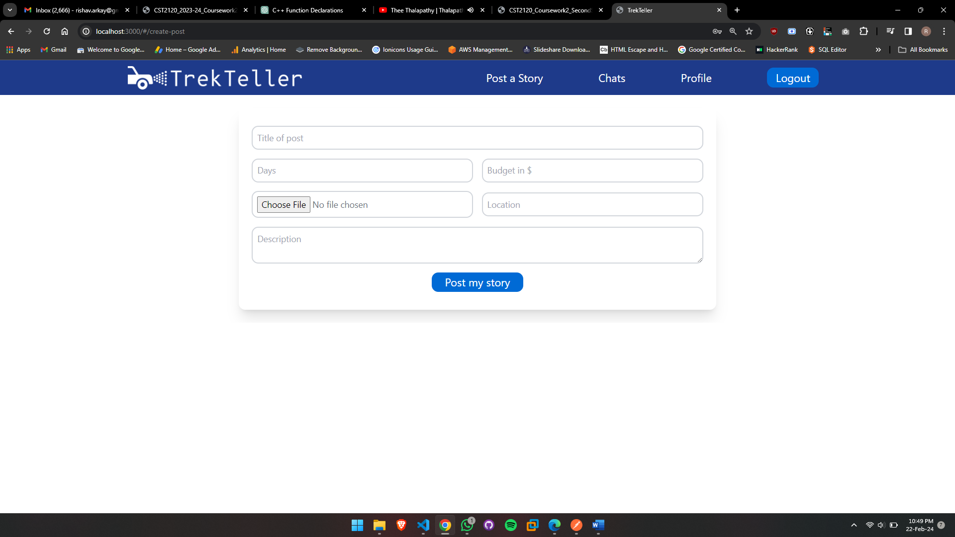

16 Create a Post Form

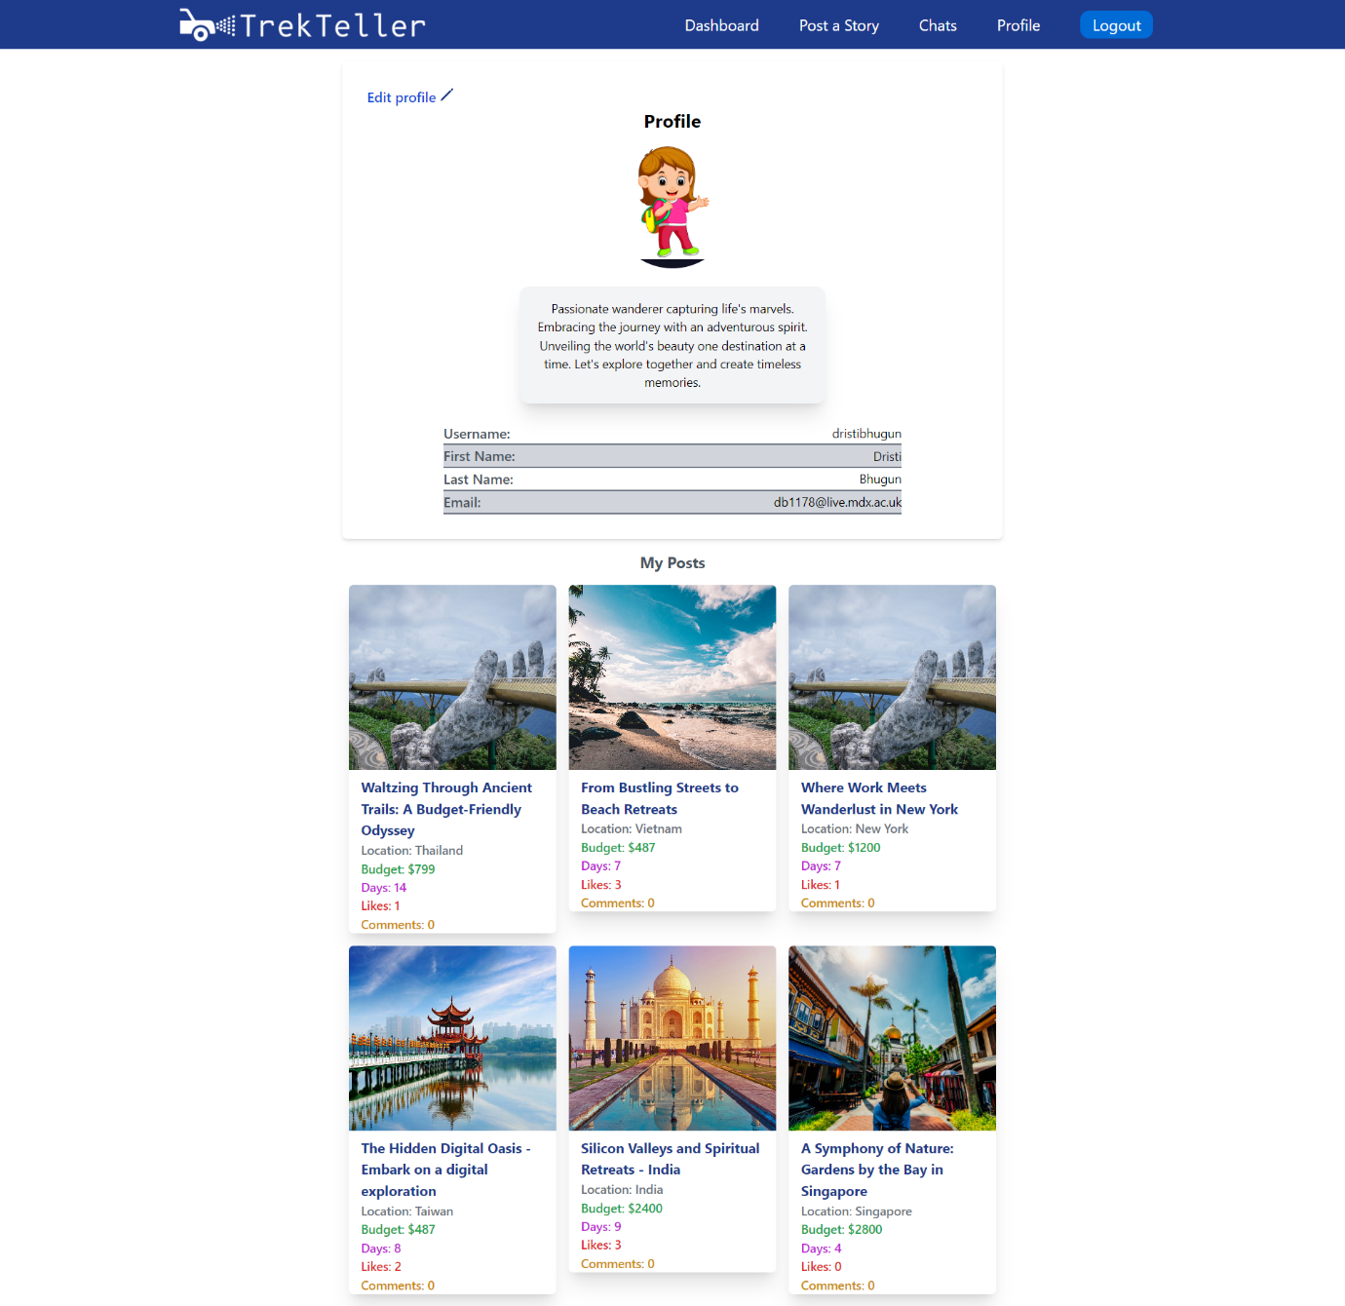

17 Profile Page

# Conclusion

In wrapping up our journey through the digital landscape of TrekTeller, we return to the core of what makes this platform not just a hub for travel stories, but a technical marvel in the realm of web-based applications. Leveraging the latest in web development technologies – HTML, Tailwind CSS, JavaScript, AJAX, Node.js, and MongoDB – TrekTeller stands as a paragon of modern web application design, ensuring a seamless, responsive, and engaging user experience.